**PROFILE**

1. Name: Dr. I. Sai Prasad 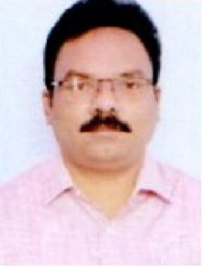
2. Designation: Associate Professor, Department of Management Studies
3. Date of Birth: 04-05-1977
4. Educational Qualifications: MBA., M.Com., Ph.D.,
5. Teaching Experience: 23 Years
6. Research Experience: 12 Years
7. Dissertation/Thesis Title: **:**  Marketing of Agricultural Products - A Case Study of Paddy in

East and West Godavari Districts of Andhra Pradesh.

1. No. of Research Publications: 14
2. No. of Books Published: 01
3. No. of Major/Minor Research projects: Nil
4. Title of Minor Research Project: Nil
5. No. of International Conference Attended: 01
6. No. of National conferences Attended: 08
7. No. of Papers Presented at the Seminars/Conferences:19
8. Refresher Courses/Orientation Programmes/Training Programmes Attended: 09
9. Vidwaan Score: Nil
10. Address: 8-6-49/1, Kummaripeta, Narsapur, 534 275, West Godavari District.
11. Email Id: [isaiprasad77@gmail.com](mailto:isaiprasad77@gmail.com)
12. Contact No: +91 9440532121